27. Develop a system using UML for Supermarket Management System.

Activity diagram:

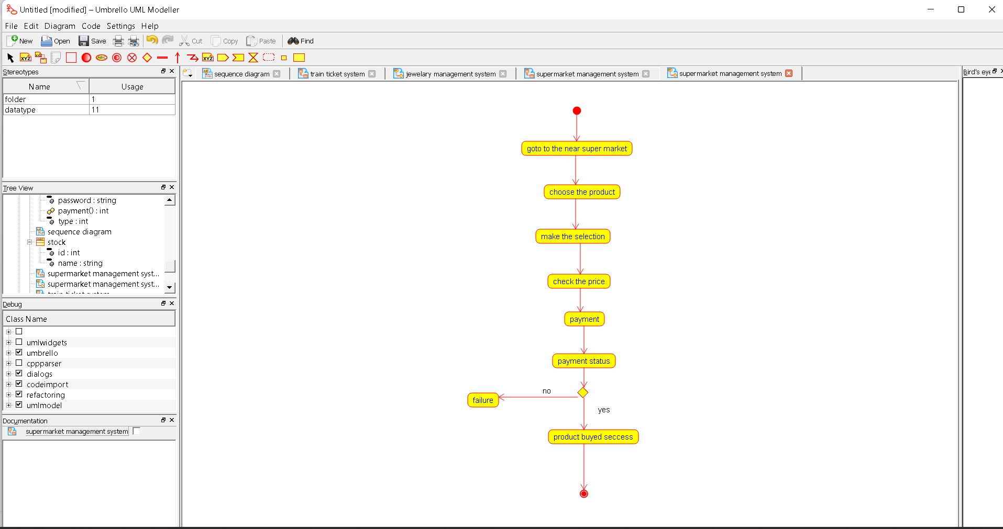

Class diagram:

